Design A Red Nose
Competition
Design a red nose for “Red Nose Day” for your chance to win a £25 Voucher.
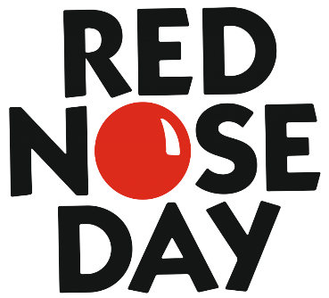
NAME:
AGE if under 16:
CONTACT NUMBER:
Go all out in your design, be as creative as you wish!
£1 to enter and all money raised goes to Comic Relief
Hand completed designs in to 302 Bridgewater place, 401 Faraday reception or Chadwick house reception desk.
Closing Date 15/03/24 at 13:00pm

